**Author: Dr. Constanze Weise**

**The Oshogbo Group**

Between 1962 and 1966, after Nigeria gained Independence from Britain, a group of artists emerged in the Yoruba town of Oshogbo in southwestern Nigeria. They participated in art workshops conducted by expatriates, particularly Susanne Wenger, Ulli Beier and Georgina Beier. The artists combined traditional subject matter and stories with Western artistic media and techniques. Many had been involved in dance, theatre and music as members of Duro Ladipo's theatre company and remained creatively linked. Their works were characterised as trans-genre and retained the performative momentum of Gesamtkunstwerk (total artwork). The artists, among them Jacob Afolabi, , Rufus Ogundele, Jimoh Buraimoh, Adebisi Fabunmi, Taiwo Olanyi (Twins Seven-Seven), Muraina Oyelami, Adebisi Akanji, Buraimoh Gbadamosi and Nike Okundaye, gained international fame and patronage, continuing with their work even after the Beiers left Nigeria. The Beiers continued to support Oshogbo artists in Sydney, Australia and Bayreuth, Germany while Susanne Wenger involved them in the artistic recreation of the Osun grove in Oshogbo itself.

In the early 1960s, three expatriate artists, the art critic Ulli Beier (1922-2011), and visual artists Georgina Betts (later Beier, *1936 ) and Susanne Wenger (Beier’s first wife, 1915-2009) settled around Oshogbo, setting an art movement in motion. At the same time playwright Duro Ladipo (1931 – 1978) arrived with his theatre group. In March 1962, Ladipo opened up his home as a cultural center housing the Oshogbo chapter of Mbari Mbayo (an outgrowth of an arts organization originating at the University of Ibadan) in his "Popular Bar." That summer, Ulli Beier organized a visual arts workshop headed by architect Julian Beinart and painter Denis Williams (1923-98). The workshop involved actors from Ladipo's troupe and young unemployed men from the neighborhood. The second workshop in 1963 was headed by Denis Williams and Jacob Lawrence (1917 – 2000) followed by a workshop led by Georgina Beier and graphic art specialist Ru van Rossem (*1924) in 1964. Over the next three years, Georgina continued to run the experimental art school in her own house.

Classes were held in the summer. The idea was that “summer school” would help students break academic routines and free them from conventions. Beier believed that art education should not be constrained by an institutional environment, and he propagated "creative freedom" through a workshop approach. Most of the Oshogbo school students were illiterate and young – under twenty. Students were given materials and asked to paint freely. Key individuals emerged from the first few workshops--Jacob Afolabi (*1940), Rufus Ogundele (1946-1996), Jimoh Buraimoh (*1943), Adebisi Fabunmi (*1945), Taiwo Olanyi (Twins Seven-Seven) (1944-2011) and Muraina Oyelami (*1940). Of the several hundred who participated in Oshogbo workshops, only a few remained to work with Georgina on a regular basis.

Georgina taught the use of material and techniques, but not the formal rules of perspective that characterized Western art. Nor did she encourage a focus on naturalism. As a facilitator, she helped each artist develop his own voice. The best-known Oshogbo artist is Twins Seven-Seven. He worked mostly in inks, gouache and oils, portraying a fantastical world inhabited by monsters and imaginary animals. A strong decorative line and pattern characterized his work. He took inspiration from Amos Tutuola's books whose own approach to narrative can be sensed through the titles -- *Strange Hunters* or *My life in the Bush of Ghosts*.

Jimoh Buraimoh began with painting, added beads and later moved into mosaic. He concentrated on heads, which bears some relation to the traditional Yoruba approach to sculpture, but also used color symbolism to suggest symbolic meanings drawn from his cultural background. Muraina Oyelami concentrated on capturing man in his environment or man in the present using palette knives, rollers and brushes in achieving effects on paper. Adebisi Fabunmi went into printmaking with a focus on urbanization, his work resembling a jigsaw puzzle of houses, windows, rivers, animals, clocks and trucks.

The Nigerian Civil war (1967 – 70) forced many Oshogbo artists to explore alternative media because art supplies were difficult to obtain. Consequently, they developed the diversity of materials that became characteristic of Oshogbo art. Adebisi Fabunmi began to work in wool, embroidery and cloth applique while Jacob Afolabi used strips of fluorescent colored plastic cut from brooms obtained at the local market.

Oshogbo artists continued working even after the Beiers left in 1966. Some actually travelled to Australia and Germany, where the Beiers provided them with workshop space. Iwalewa House linked to the African Studies Center (University of Bayreuth) and founded by Beier in 1981 provided a place for interaction between artists from all over the world.

Susanne Wenger remained in Nigeria and continued to work with artists in Oshogbo. She introduced students to cement sculpture and involved them in the recreation of the Osun shrine, particularly stone carvers Adebisi Akanji (*1945) and Buraimoh Gbadamosi (*1936). Oshogbo remains a center of art production, but with many fewer artists. However, some of the original “graduates" continued to build skills and artistic reputations. Female artists also emerged, notably Nike Okundaye (*1951) well known for her batik and for the art centers she has established to provide women and youth with craft skills, empowering them economically.

A surrealistic blend of inherited knowledge of Yoruba cosmology and new media characterized Oshogbo art and gave it vitality. Shared features of Oshogbo artists’ work remain the joining of supernatural and natural whether depicting mythic narrative or genre scenes and using a flat, decorative style and an expressionistic manner, lending their works a modern character.

The first exhibit of Oshogbo school artists occurred in Lagos in 1965, bringing the group international acclaim. Exhibits in Europe and the United States followed and contributed to the artists’ global recognition.

**References and further reading**

Beier, U. (1991) *Thirty Years of Oshogbo Art*, Bayreuth, Germany: Iwalewa.

Glassie, H. (2010) *Prince Twins Seven-Seven: His art, His life in Nigeria, His exile in America*. Bloomington, Ind: Indiana University Press.

Kennedy, J (1991) New *Currents, Ancient Rivers: Contemporary African Artists in a Generation of Change*, Washington: Smithsonian Institution Press.

Okeke-Agulu, C. (2013) 'Rethinking Mbari Mbayo: Osogbo Workshops in the 1960s, Nigeria', in: Sidney Littlefield Kasfir and Till Förster (eds.), *African art and Agency in the Workshop*. Bloomington: Indiana University Press: 154-79.

Probst, P. (2011) *Osogbo and the Art of Heritage*, Bloomington: Indiana University Press.

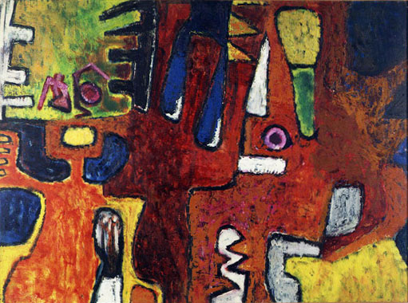

Rufus Ogundele (1946 – 1996), Kings Appealing to the God of Iron, 1965

946–1996, Nigeria  
*Kings Appealing to the God of Iron,* 1965   
Oil on wood  
90.9 x 122.3 cm (35 13/16 x 48 1/8 in.)   
Lent by Mimi Wolford/Mbari Institute for Contemporary African Art

http://africa.si.edu/exhibits/oshogbo/ogun_I.htm

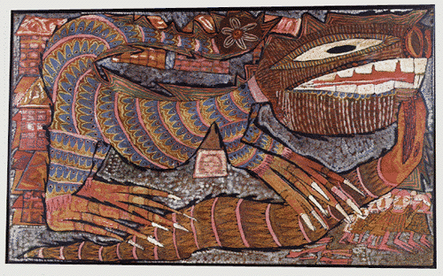

*Twins-Seven Seven (1944- 2011), Nigeria*

*The Lazy Hunters, and the Poisonous Wrestlers, Lizard, Ghost and the Cobra,* 1967   
Ink, paint, chalk on plywood   
124.5 x 78.1 cm (49 x 30 3/4 in.)  
National Museum of African Art, gift of Mr. and Mrs. Sean Kelly, 75-28-3

<http://africa.si.edu/exhibits/oshogbo/twins_I.htm>

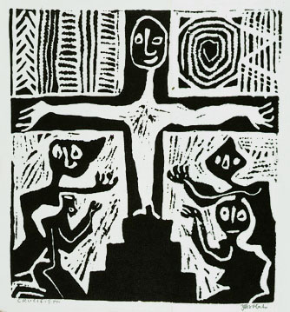

Jacob Afolabi (*1940, Nigeria)  
*Crucifixion,* 1960s   
Ink on paper  
30.7 x 28.2 cm (12 1/16 x 11 1/8 in.)  
Collection of Carol Fitch and David Fitch

<http://africa.si.edu/exhibits/oshogbo/afolab_I.htm>

<http://whc.unesco.org/en/list/1118/gallery/>

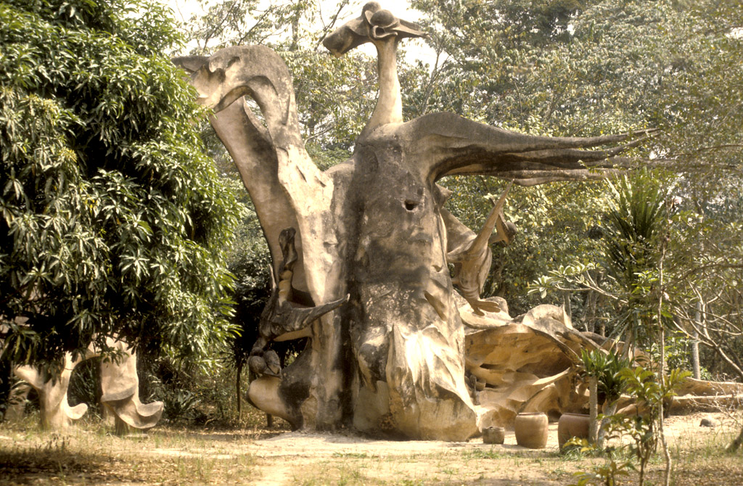

Iya Moopo, Susanne Wenger and Assistent Adebisi Akanji, Osun Grove Oshogbo, 1967

Iya Moopo, the goddess who is both pot and potter, the patroness of all women's occupations, including a woman's erotic vocation, of conception and child birth.

<http://www.susannewengerfoundation.at/home.php?il=13&l=eng>

Check also:

The sacred grove is a Unesco world heritage site. Perhaps copy right permission and more detailed information about the sculpture can also be obtained from there

http://whc.unesco.org/en/list/1118